LETTER OF RECOMMENDATION 2020-2021
For GRIPS use: Application ID

TO THE APPLICANT: Please complete this section (“Your name” and “Recommender’s name”), and give this form to your recommender who knows you well. Have your recommender complete the form, put it in an envelope, seal the envelope, sign it across the flap, and return the letter to you. Include this letter with your application and all the other application materials when you send in your application.
Your name:
As written in your passport, from left to right, top to bottom (English alphabet only)
Recommender’s name:

TO THE RECOMMENDER: Please write a recommendation letter for the above applicant, sign it, enclose it in an envelope, seal the envelope, and sign it across the flap. Return the sealed envelope to the applicant or send it directly to the GRIPS Admissions Office. This recommendation letter will remain confidential and will be used for application screening purposes only. You may attach additional sheets if the space provided is insufficient.

1. | How long have you known the applicant? |  |  |  |  |  |  |  |  | years |  |  |  |  |  |  |  | months
2. | In what capacity have you known the applicant?
3. | How often have you interacted with the applicant?
 | Daily Weekly Monthly Rarely
4. | In comparison with other students/staff whom you have known in the same field, how would you rate the applicant’s overall academic ability?  Outstanding (top 5%)  Excellent (top 10%)  Good (top 20%)  Average (top 50%)  Below average (lower 50%)  Unable to comment
5. | In comparison with other students/staff whom you have known in the same field, how would you rate the applicant’s overall professional ability?  Outstanding (top 5%)  Excellent (top 10%)  Good (top 20%)  Average (top 50%)  Below average (lower 50%)  Unable to comment
6. | Please evaluate the applicant in the areas below as excellent, average, poor, or unable to comment.
 |  | Excellent |  |  | Average |  |  |  | Poor |  |  |  |  | Unable to comment
 | Academic performance
 | Intellectual potential
 | Creativity & originality
 | Motivation for graduate study

7. | Discuss the applicant's competence in his/her field of study, as well as the applicant's career possibilities as a professional worker, researcher, or educator. In describing such attributes as motivation, intellectual potential, and maturity, please discuss both strong and weak points. Specific examples are more useful than generalizations.
8. | Discuss the applicant's character and personality. Please comment on his/her social skills, emotional stability, leadership skills, and reliability.
9. | For university professors and instructors only  Is the applicant’s academic record indicative of the applicant's intellectual ability? If no, please explain.
10. | Additional comments, if any.
11. | How would you evaluate the applicant's overall suitability as a candidate for admission to a graduate program at the National Graduate Institute for Policy Studies?
 | Outstanding Good Average Poor

Name of person completing this form:
Position/title:
Name of organization:
Address:
TEL: |  |  | FAX: |  |  |  | E-mail:
 | Country code - complete number |  |  |  | Country code - complete number
Signature: |  |  |  |  |  | Date:
 |  |  |  |  |  |  | Month/Day/Year

健康診断書
CERTIFICATE OF HEALTH (to be completed by the examining physician)

日本語又は英語により明瞭に記載すること。
Please fill out (PRINT/TYPE) in Japanese or English. Do not leave any items blank.

氏名 □男 Male 生年月日 年齢
Name : □女 Female Date of Birth : Age :

Family name, First name Middle name

１．身体検査 Physical Examinations

(1) 身 長 体 重
Height cm Weight kg
ＲＨ ＋
－

A B O
(2) 血 圧 血液型
Blood pressure mm/Hg～ mm/Hg Blood Type

脈拍数 □整 regular
Pulse Rate ＿＿＿/min □不整 irregular

(3) 視 力
Eyesight : (R) (L) (R) (L)
裸眼 without glasses 矯正 with glasses or contact lenses

(4) 聴 力 □正常 normal 言 語 □正常 normal
Hearing : □低下 impaired speech : □異常 impaired

２．申請者の胸部について，聴診とＸ線検査の結果を記入してください。Ｘ線検査の日付も記入すること（6ヶ月以上前の検査は無効｡)
Please describe the results of physical and X-ray examinations of applicant's chest x-ray (X-ray taken more than 6 months prior to the certification is NOT valid).
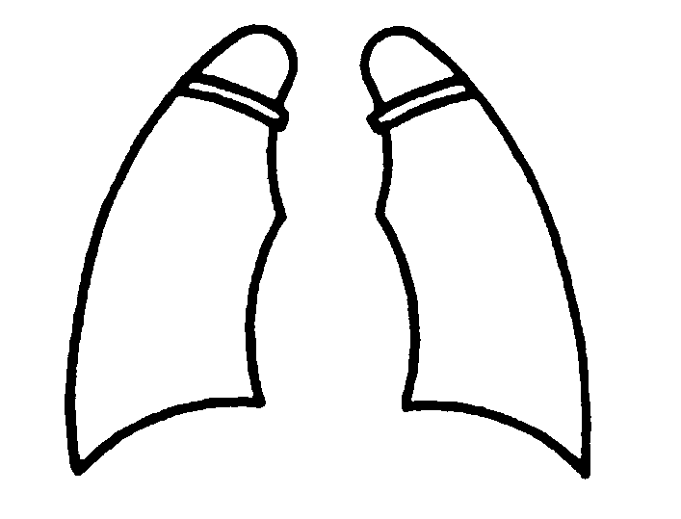
肺 心臓
lung: □正常 normal Date Cardiomegaly:□正常 normal
□異常 impaired □異常 impaired
Film No.
心電図
Electrocardiograph
□正常 normal □異常 impaired

Describe the condition of applicant's lung.

３．現在治療中の病気 □Yes (Disease: Medicine: )
Disease & Treatment at Present □No

４．既往症 Past history : Please indicate with ＋ or － and fill in the date of recovery.

Tuberculosis……□( . . ) Malaria……□( . . ) Measles……□( . . )
Epilepsy……□( . . ) Kidney disease……□( . . ) Heart diseases……□( . . )
Diabetes……□( . . ) Drug allergy……□( . . ) Psychosis……□( . . )
Functional disorder in extremities……□( . . ) Others……□( . . )
Rheumatic fever……□( . . ) Hepatitis……□(Type: A, B, C, D, E) ( . . )

５．ワクチン接種歴 Vaccination history

MMRV (Measles, Mumps. Rubella, Zoster)……□ Time(s) ( ) Mumps……□ Time(s) ( ) Hepatitis B……□ Time(s) ( )
MMR (Measles, Mumps. Rubella)……□ Time(s) ( ) Chicken pox……□ Time(s) ( ) Meningitis……□ Time(s) ( )
MR (Measles, Rubella)……□ Time(s) ( ) Polio……□ Time(s) ( )
M (Measles)……□ Time(s) ( ) Diphtheria Pertussis Tetanus combined……□ Time(s) ( )

６．検 査 Laboratory tests
検 尿 Urinalysis:glucose( ),protein ( ),occult blood ( )・検 便 Feces: Parasite(egg of parasite)(+,-)
赤沈 ESR : mm/Hr, WBC count : x10³/μl, Hemoglobin: g/dl, ALT: u/l
Pregnancy test ( ) if you are female

７．診断医の印象を述べて下さい。 Please describe your impression.

８．志願者の既往歴，診察・検査の結果から判断して，現在の健康の状況は充分に留学に耐えうるものと思われますか？
In view of the applicant's history and the above findings, is it your observation his/her health status is adequate to pursue studies in Japan？ yes □ no □

日付 署名
Date: Signature:

医 師 氏 名
Physician's Name in Print:

検査施設名
Office/Institution:

所在地
Address:

