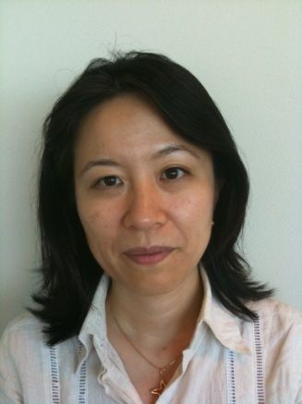
Yuka (Uchida) Ando (Japan)
Dissertation topic:
“Development of Japan's ODA to Palestine from 1960 to 2003”
Research interests:
Japanese foreign policy and Middle Eastern affairs (relationship with Western powers and the Middle East)
e-mail: yukauchida@hotmail.com

Publications
Yuka Uchida, “Arab Spring and US abandonment of anti-Democratic regimes in the Middle East”, ‘Chuo-koron’(Monthly), April 2011

Yuka Uchida, “My Grandfather, Masamichi Inoki”, periodical magazine ‘G2’, December 2009

Yuka Uchida, “The Time when there was a ‘Real Arabist’ in England ---Gertrude Bell and the Transfer of Power in Iraq”, ‘Ronza’(Monthly), August Issue, 2004

Presentations
September 25th, 2012(Washington, D.C., USA): Panel discussion at US Congress for Congressional staff (Japan Center for International Exchange’s study group presentation)
Title: “Political Leadership in Japan”

July 25th, 2012(Washington, D.C., USA): Presentation at The Wilson Center’s Asia Program and Middle East Program, Woodrow Wilson International Center for Scholars
Title: “Japan’s Middle East Policy since 9/11”

Working Experience
2012 May -2012July
Public Policy Scholar, Woodrow Wilson International Center for Scholars
2011December - 2012 January
Political Secretary for State Minister, Natonal Public Safety Commission, Consumer Agency and Abduction of Japanese Citizens Affairs
2011 August - 2011 December
Visiting Fellow, Brookings Institution, Center for North Asian Policy Studies (CNAPS)
2010 September - 2011 March
Political Secretary for Foreign Minister
2010 - 2002
Staff at the Democratic Party of Japan (DPJ) headquarters
(last post as Assistant General Manager, International Department)
2000 - 2002
Special Assistant for the political affairs, the Embassy of Japan, Kuwait

Education
MA in American Foreign Policy from Johns Hopkins Univ., School of Advanced International Studies (SAIS), Washington, D.C.
BA in Political Science from Keio University, Law Department

Languages
Japanese (native), English (Fluent)

