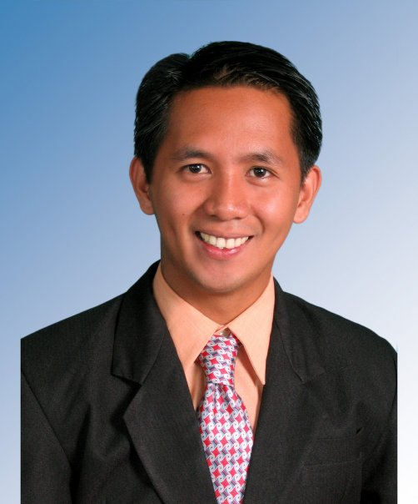 | Orville BALLITOC (Philippines)  Dissertation Topic:  “Conflict Cycles and Spoiler Problems in the  Southern Philippines”  Research Interests:  Contemporary history of the Southern Philippines; Political economy of Mindanao; Conflict Resolution; Comparative politics; and International Relations in Southeast Asia
Email: doc10115@grips.ac.jp or noc_ballitoc@yahoo.com

Presentations:
November 2013, Bangkok (Thailand), Presentation at Asia-Pacific Peace Research
Association (APPRA) Conference 2013
Title: “Spoiler Problems in Cyclical Conflicts: The Experience of the Southern
Philippines”

July 2012, Chiang Mai (Thailand), Presentation at the International Conference on
International Relations and Development (ICIRD) 2012
Title: “Cycles of Conflict and Violence in the Southern Philippines”

August 2010, Tokyo (Japan), Presentation at the GRIPS Student Forum on the Philippines
Title: “The Politics of Guns, Goons, Gold and Glamour in the Philippines”

Current Status: PhD Candidate

Work Experience:

Legislative Staff, Office of Congressman Bernardo F. Pinol, Jr.
Member, Philippine House of Representatives
2nd District, North Cotabato Province, Philippines
August 2007-March 2008

Consultant for Linkages and Fund Generation,
Office of the President, Ifugao State University (IFSU)
Ifugao Province, Philippines
June 2007-March 2008

Elected Municipal Councilor
Local Government Unit of Lamut, Ifugao, Philippines
June 2004 –May 31, 2007

Instructor, Public Administration and Political Science
School of Public Administration and Governance (SPAG)
Saint Mary’s University (SMU), Bayombong, Nueva Vizcaya, Philippines
2002 – 2006

Secretary to the Dean, School of Public Administration and Governance (SPAG)
Saint Mary’s University (SMU), Bayombong, Nueva Vizcaya, Philippines
2002 – 2004

Education:

Ph.D. Candidate in International Relations
National Graduate Institute for Policy Studies (GRIPS)
Tokyo, Japan

Master of Public Policy, 2010
National Graduate Institute for Policy Studies (GRIPS)
Tokyo, Japan

Intensive Japanese Language Course, 2009
Japan Student Services Organization (JASSO), Tokyo Japanese Language Education Center
Kita-Shinjuku, Tokyo, Japan

Bachelor of Arts in Public Administration, 2001
National College of Public Administration and Governance (NCPAG)
University of the Philippines (UP)
Diliman, Quezon City, Philippines

Languages: Filipino (native), English (Fluent), Japanese (proficient)

Facebook: Orville Ballitoc

