KDI SCHOOL ADMISSION of CAMPUS Asia PROGRAM
For 2015 FALL SEMESTER OPEN
Dear Partner Schools,
Greetings from the KDI School, Sejong, Korea!
It is our pleasure to inform you that the KDI School CAMPUS Asia Program for inbound students’ admission is open!
The KDI School Fall Semester starts on Sep 12th and ends on Dec. 12th, 2015.
We welcome any candidates who are interested in and are eligible for the CAMPUS Asia program at the KDI School!
Additionally, KDI School is newly moved its campus to Sejong City. Located at the heart of the multifunctional administrative city, the KDI School’s new campus offers world-class education taking advantage of its geographical proximity to central government agencies and national research institutes. The Sejong campus offers optimum educational environment by providing students with up to-date research and educational facilities.

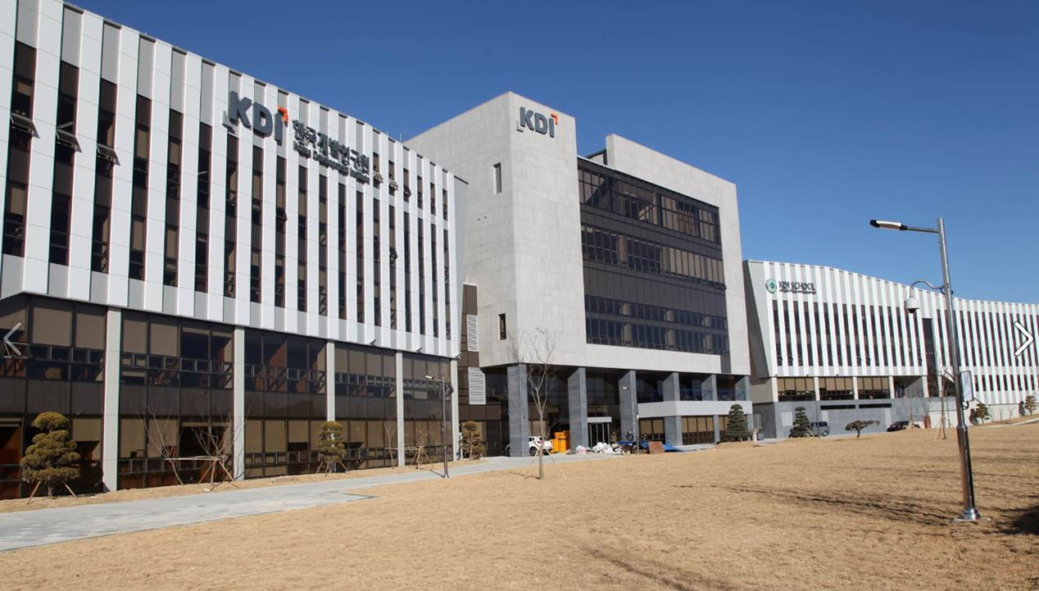

<Application Information for 2015 Fall>
1. Application Deadline: 1st, May (1th week Friday of May.) 2015
: True certified copies or originals should be submitted by postal mail to the address below by 8th, May.
2. Required Documents
- Nomination Letter from parent institution
- One Recommendation letter
- Application Form (Attached)
- Statement of Purpose (Attached)
- Resume (Attached)
- Official Transcripts (Bachelor & Master)
- Official Certificate of Graduation (Bachelor)
- 1 ID Photo
- Copy of passport
- TOEFL Score (or IELTS or TOEIC) * For those whose mother tongue is English does not needed.
3. Benefits
- No extra tuition will be charged at the KDI School.
- Financial support at 900,000 KRW per month for living expenses will be provided.
- Extra cultural events and curriculums will be available free of charge.

Thank you for your cooperation in advance.

Kaithy Hyun Joo Kim (김현주, 金賢柱)
Student Affairs, 학생지원팀 선임전문원
KDI SCHOOL of Public Policy and Management , 한국개발연구원 국제정책대학원
263(Bangok-dong, KDI SCHOOL), Namsejong-ro, Sejong-si 339-007, Republic of Korea
세종시 남세종로 263(반곡동) 우: 339-007
TEL: 044-550-1253ㅣFAX: 044-550-1232ㅣEMAIL: hj_kim@kdischool.ac.kr
http://www.kdischool.ac.kr

