KDI SCHOOL ADMISSION of CAMPUS Asia PROGRAM
For 2015 SPRING SEMESTER OPEN
Dear Partner Schools,
Greetings from the KDI School, Seoul, Korea!
It is our pleasure to inform you that the KDI School Exchange Program for inbound students’ admission is open!
The KDI School Spring Semester starts on Feb 9th and ends on May 9th, 2015.
We welcome any candidates who are interested in and are eligible for the Exchange program at the KDI School!
Additionally, KDI School is scheduled to move its campus to a different city called Sejong, located about 200km away from Seoul. The move will take place in December 2014, so please note that you stay in the newly built campus in Sejong city.

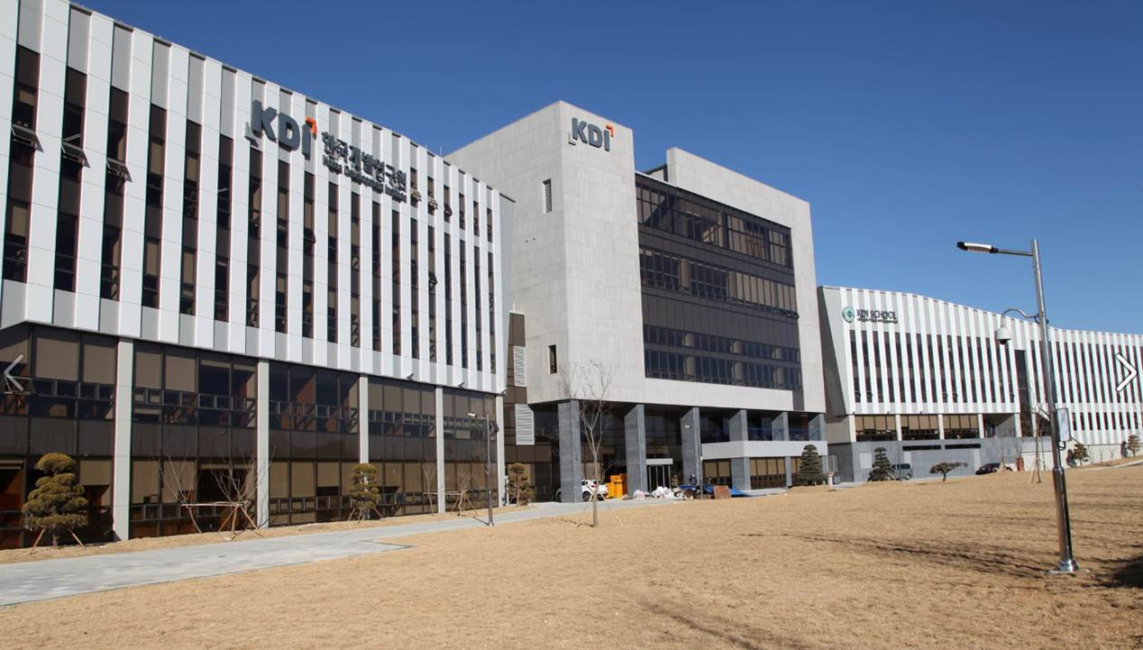
<Application Information for 2015 Spring>
1. Application Deadline: 2, November (1th week Sunday of Nov.) 2015
: True certified copies or originals should be submitted by postal mail to the address below by the deadline.
2. Required Documents
- Nomination Letter from parent institution
- One Recommendation letter
- Application Form (Attached)
- Statement of Purpose (Attached)
- Resume (Attached)
- Official Transcripts (Bachelor & Master)
- Official Certificate of Graduation (Bachelor)
- 1 ID Photo
- Copy of passport
- TOEFL Score (or IELTS or TOEIC) * For those whose mother tongue is English does not needed.
3. Benefits
- Credits earned from the KDI School may be transferred as according to GRIPS regulations. (Maximum 10 Credits)
- No extra tuition will be charged at the KDI School.
- Financial support at 900,000 KRW per month for living expenses will be provided.
- Extra cultural events and curriculums will be available free of charge.

Thank you for your cooperation in advance.

Kim, Hyun Joo
Student Affairs Division.
KDI School of Public Policy and Management
85 Hoegiro Dongdaemun-Gu, Seoul,130-868, Korea
Tel: 82-2-3299-1253

